Peach Tree and Lower Surveyors creeks FLOODPLAIN RISK MANAGEMENT STUDY AND PLAN

information SHEET

INTRODUCTION
In 2019, Penrith City Council completed a detailed flood study for the Peach Tree and Lower Surveyors Creeks catchment. The extent of the study area is shown on the following page. Council is now preparing a Floodplain Risk Management Study and Plan for the catchment, and we would like your help. The study will inform us about the possible flood management measures needed and help us plan for and manage known flood risks. Sound flood management based on local knowledge will help Council reduce flood damage and risk, enhance resilience and improve social and economic opportunities.

Council has appointed engineering consultants Catchment Simulation Solutions to prepare the study and plan on our behalf. The study will be overseen by the Penrith Floodplain Risk Management Committee and receive financial support from the State Government under its Floodplain Management Program.

WHY have A FLOODPLAIN RISK MANAGEMENT STUDY AND PLAN?
The Penrith Local Government Area (LGA) is dominated by rivers, creeks and waterways and has wide floodplains. The risk of flood is real, and Council wants to ensure proper plans are in place in accordance with the NSW Government Flood Prone Land Policy.

The policy sets out the staged process we are following, which includes data collection; a flood study; a floodplain risk management study and plan; and the implementation of the plan. Council is now starting the floodplain risk management phases for the Peach Tree and Lower Surveyors Creeks catchment as highlighted in yellow below.

The Floodplain Risk Management Study identifies and evaluates measures that could be incorporated into the Floodplain Risk Management Plan to reduce the risk and cost of flooding to the community; assist with emergency management and guide future development. The process also looks at making the community more resilient including preparation, education, and evacuation.

MAP OF STUDY AREA UNDER CONSIDERATION
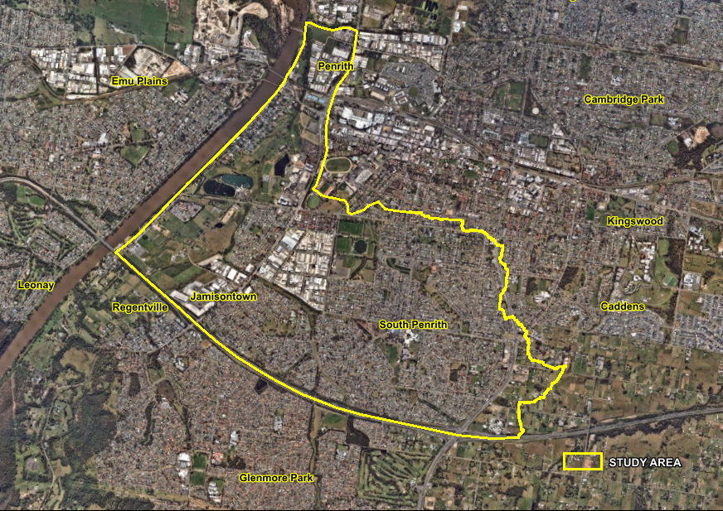

WHAT’S INVOLVED IN PREPARING A FLOODPLAIN RISK MANAGEMENT STUDY?
A considerable amount of work goes into preparing a Floodplain Risk Management Study and Plan, including:
- identifying areas at risk of flooding using computer modelling (completed in 2019) and from information you provide in the community questionnaire.
- developing a range of options for managing flood risk, such as: modifying creek channels, detention basins, stormwater upgrades, constructing levees, enforcing planning controls for new development and planning for evacuation, education, and awareness.
- analysing the options, considering environmental, social and economic benefits, as well as their potential to reduce flood risk.
- preparing a Floodplain Risk Management Study Report, which summarises the outcome of all stages of the investigation and makes recommendations to be carried forward to the Floodplain Risk Management Plan.

HOW CAN you BE INVOLVED?
Your local flood knowledge and personal experience of living in the area is invaluable when identifying flood ‘trouble spots’ and developing floodplain risk management measures that are practical, comprehensive and effective.
The study team will consult with the community in two stages:
- Questionnaire – Please complete the questionnaire included with this information sheet and share with us your experiences of local flooding and opinions on flood management options. The questionnaire can also be completed online at yoursaypenrith.com.au.
This study is focusing on the local and overland flooding associated with the Peach Tree and Lower Surveyors Creeks Catchment. Flooding across the lower parts of the catchment from the Nepean River will also be considered.
- Community drop-in session – once the draft Floodplain Risk Management Study report is prepared, a community drop-in session will be held to give you an opportunity to review the report and ask questions about the flood management options investigated. Any comments and feedback received during this community drop-in session will be reviewed and addressed as part of the final report.

stay up to date
Our website will be updated throughout the study and plan process to provide the latest available information including details of the above community consultations. Go to the Flood Management page of www.penrith.city

More INformation
If you have any questions or would like to submit any information you think may be helpful to the study, please contact:

Habib Rehman - Penrith City Council
PO Box 60, Penrith NSW 2751
Phone: 4732 7777
Email: council@penrith.city

